**Ideation Phase**

**Define the Problem Statements**

|  |  |
| --- | --- |
| Date | 06 May 2023 |
| Team ID | NM2023TMID14798 |
| Project Name | AuditAI: A Machine Learning for Detecting Fraud in Audit Data |
| Maximum Marks | 2 Marks |

**Customer Problem Statement Template:**

Fraud is a serious issue that can have serious consequences for businesses and individuals. Detecting fraud is important because it can help prevent significant financial losses and protect the integrity of a company or organization. There are several reasons why it is important to detect fraud. Fraud detection is a collection of processes and techniques designed to identify, monitor and prevent fraud. In the online business world, fraud, scams, and bad agents are damaging in a number of ways. Companies have to put steps in place to ensure that fraud is detected and stopped before it affects business. Using audit data for fraud detection involves analyzing financial and operational data from a company’s audit to identify patterns or anomalies that may indicate fraudulent activity. Audits provide a comprehensive view of a company’s financial and operational activities, making them a valuable source of data for fraud detection.

**AuditAI: A Machine Learning for Detecting Fraud in Audit Data**

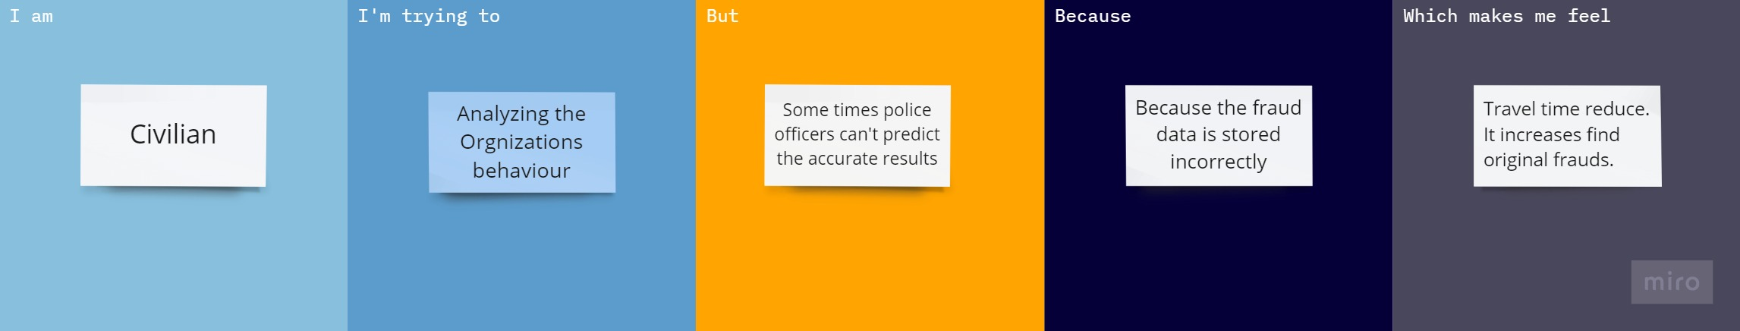

|  |  |  |  |  |  |
| --- | --- | --- | --- | --- | --- |
| **Problem Statement (PS)** | **I am (Customer)** | **I’m trying to** | **But** | **Because** | **Which makes me feel** |
| PS-1 | Civilian | Analyzing the organizations behaviour | Sometimes the police officer can’t predict the accurate results | The fraud data is stored incorrectly | Travel time reduce.It increase to find original  frauds |
| PS-2 | Bank Officer | Analyzing the customers behaviour | Sometimes the customer account to be hacked | The fraud data is stored incorrectly | Easy to recover the customer account. |